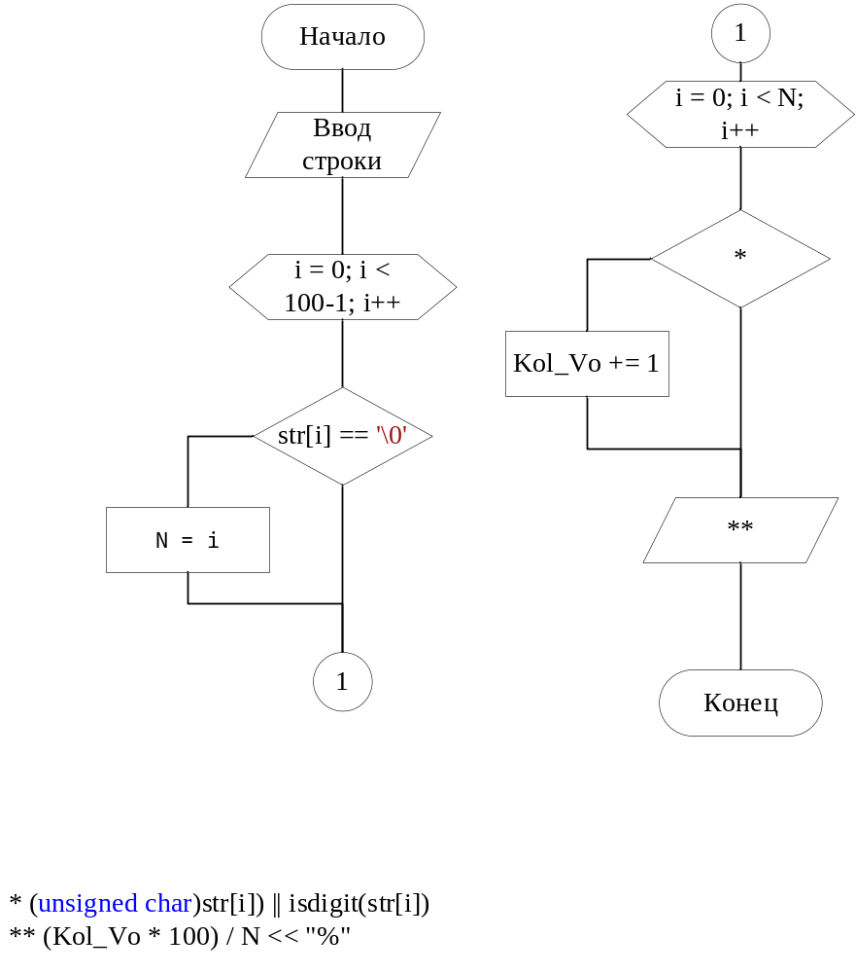
#include <iostream>
#include <cctype>
#include <windows.h>
using namespace std;
int main()
{
setlocale(LC_ALL,"ru");
SetConsoleCP(1251);
SetConsoleOutputCP(1251);
char str[100];
int N = 0;
int Kol_Vo = 0;
cout << "Введите строку: " << endl;
gets_s(str);
for (size_t i = 0; i < 100-1; i++)
{
if (str[i] == '\0') {N = i;}
}
for (size_t i = 0; i < N; i++)
{
if (isupper((unsigned char)str[i]) || isdigit(str[i])) {Kol_Vo += 1;}
}
cout << (Kol_Vo * 100) / N << "%";

return 0;
}

